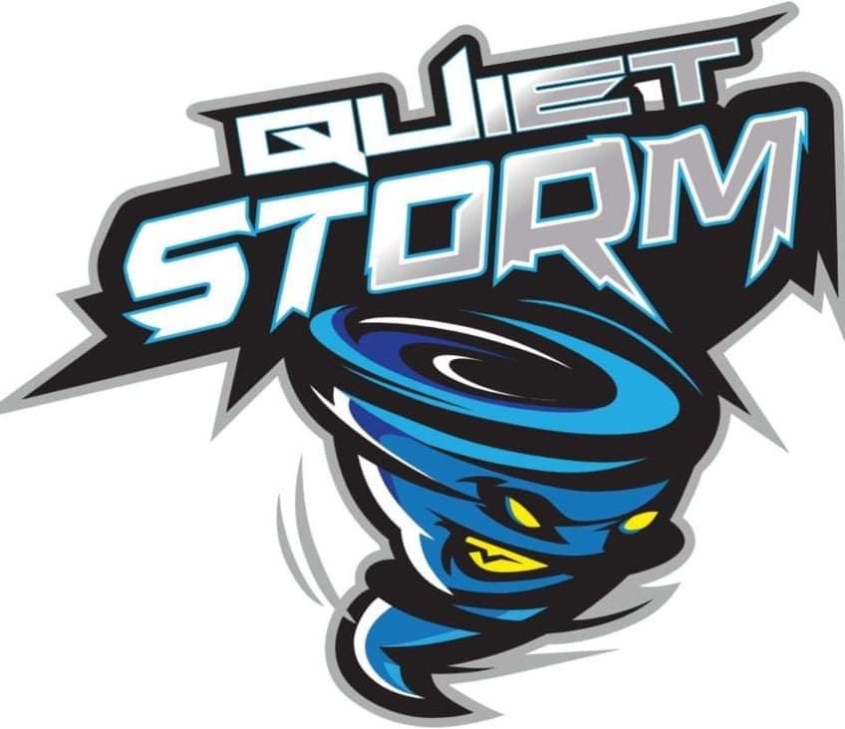

QUIET STORM TRACK ASSOCIATION SPONSORSHIP PROPOSAL 2021-2022

OVERVIEW
Quiet Storm Track Club Association was founded in August of 2019 in Jacksonville, FL. QSTA is seeking a sponsorship to move forward in our traveling track club program with the objective of helping our at-risk youth. We are a program of 80 youth and growing ranging from ages 6-19. Quiet Storm Track Club gives children an outlet to feel free of emotional and physical distress they may feel in their home or in their neighborhood. Our track program not only provides track but provides tutoring, counseling, and a safe environment. Track clubs have been very useful for children wanting to get into colleges through scholarships and pursuing dreams to becoming the greatest Olympians. Funding and sponsorship in the amount of $50,000 is requested for chaperon and athlete travel expense, nourishments while traveling, registration of the meets, and to help offset the cost for the unfortunate that would like to be part of the team. Our program is designed to give our youth a chance to become leaders and law-abiding citizens, Quiet Storm Track Club gives hope in a way out of no way. We as an organization will travel around the U.S. competing. There is a need for our track club association, we can and will save our youth! Quite Storm Track Club feels that if these youth are not given an opportunity to show their gifts and talents in such club, as studies show youth that live-in poverty-stricken areas are more likely to be truant, drop out of school, and become involved with alcohol and illegal drugs.

Achievements
#1 ranked 13-14 year old boys 4X400 relay in the Nation
#2 ranked 17-18 year old boys 4X100 relay in the Nation
#2 ranked 15-16 year old boys 4X800 relay in the Nation
#5 ranked 11-12 year old girls 4X400 relay in the Nation
#2 ranked 11-12 year old girls 4X800 relay in the Nation
19-20 All Americans (Top 8 in Nation) Tamai King, Marvin Royal Jr., Kentwann Wooten, Aalaiya Pratt, Tahlya King, Samari Barrington, Zoriah McQueen, Mario Pratt III, Dy'aundra Ford, DeAngelo Ford Jr, Jalen Cooper, La'Shaunti Pullins, Xavier Cotton, Kamari Wyche
19-20 National Champions (#1 in Nation) Jalen Cooper, Kentwann Wooten
20-21 All Americans (Top 8 in Country) Tamai King, Aalaiya Pratt, Tracy Pratt Jr., Samari Barrington, Maleah Smothers, Tahlya King, Parris Lee, Amara Powell, Taylor Thomas, Elijah VanBuren, Naeem Burroughs, Justyn Bland, Trenard Folson, Cornelius Cooks, Quincy Burroughs, Jalen Cooper, Brandon Webb, Xavier Cotton, Chase Collier, Desean Buist, Tyrone Ouserman, Jordan Johnson, Dejon Gillins, Eric Bryant Jr.
20-21 national Champions (#1 in Nation) Brandon Webb, Jalen Cooper, Xavier Cotton, Chase Collier
Quiet Storm has now been Invited to be a part of one of the largest and most competitive organizations in youth track and field “Speed Capital”! Quiet Storm is now raked one of the TOP youth track and field teams in the Nation.
TEAM SPONSORSHIP

QSTA is always looking to align itself with companies that are interested in promoting youth mental and physical health and wellness through association with our organization. At present we are attempting to raise $50,000.00 to cover the cost of TEAM uniforms, travel to race expenses, race entry fees and other basic operating costs. Each year QSTA members participate, individually or as group, in over 50 different events in Florida and throughout the US. The bulk of the track and field “season” takes place from February through August (see the QSTA website for a complete list of events.) QSTA presence at these events along with frequent podium finishes offer sponsors the opportunity to gain invaluable exposure. Your logo placed on our website www.quietstormtrackassociation.com and other promotional material is an opportunity to show your support and association for a worthwhile, successful program. Given proper notice, the TEAM is also available for appearances at trade shows, community events, promotional gatherings, and photographic purposes. QSTA is open to all ideas to help sponsors benefit from their association with our organization.

PRODUCT SPONSORSHIP

In lieu of a monetary donation, the TEAM will accept donations in the form of products or services. This type of donation will have to equate to a specific dollar amount and depending upon the type of item/service will have to be made available to ALL our TEAM members for use over the course of the season. Product sponsorships are carefully reviewed on an item by item basis.

5 Levels of Sponsorship

- LEVEL 1 – $10,000 +
1. Exclusive two-year title sponsorship package of TEAM.
2. Exclusive Plaque of sponsorship from team.
3. Maximum exposure on the QSTA website (special page)
4. Full access to the TEAM for promotional purposes (appearances, photo
shoots, etc.)
5. ANY additional requests sponsor might require.

- LEVEL 2 - $5,000
1. Two-year secondary sponsorship package of TFL.
2. Team Plaque for sponsorship of team.
3. Logo & link placement on TFL website
4. Two TEAM appearances for promotional purposes.

- LEVEL 3 - $2,500
1. One year sponsorship package of the TEAM.
2. Team Medal of support and sponsorship.
3. Logo & link placement on TFL website.
4. One TEAM appearance for promotional purposes.

- LEVEL 4 - $1,250
1. One year sponsorship of the TEAM.
2. Team Medal of support and sponsorship
3. Logo & link placement on website.

- LEVEL 5 – Support ($100 or more)
1. Logo & link placement on website.
2. Customized picture of team.

